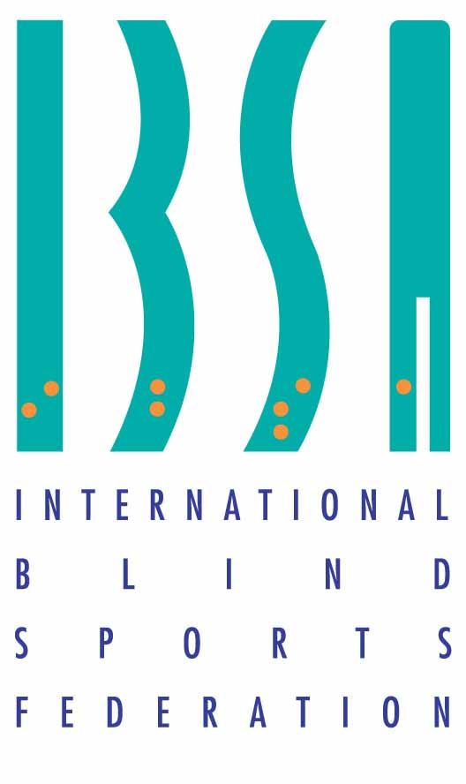
IBSA International Blind Sports Federation
Kurt Schuhmacher Strasse 22
53113 Bonn, Germany
www.ibsasport.org

17.05.2023
List of officially European qualified and nominated athletes for IBSA World Games 2023 to be held in Birmingham (United Kingdom)

IBSA Tenpin bowling Sports committee reserves the right to adjust any changes in co-ordination with the IBSA World Games LOC and the competition schedule.
The IBSA Tenpin bowling Sports committee has decided upon the final results for the official list of all athletes from Europe including two wild cards provided.
B1 Men singles category:
- Zdzyslaw Koziej (Poland)
- Shlomo Lezmy (Israel)
- Vasile Tinu Pop (Romania)

B1 Women singles category:
- Karolina Rzepa (poland)
- Slot not seeded

B2 Men singles category:
- Mieczyslaw Kontrymowicz (Poland)
- Stanislaw Stoperzynski (Poland)
- Jaromír Hasala (Czech Republic)
B2 Women singles category:
- Jadwiga Rogacka (Poland)
- Danuta Odulinska (Poland)

B3 Men Singles category:
- Kari Sipi (Finland)
- Cezary Gibinski (Poland)
- Roman Matouš (Czech Republic)

Wild card provided:
Miroslav Marcinko (Slovakia) as best new country zone athlete

B3 Women singles category:
- Zofia Sarnacka (Poland)
- Dorota Kurek (Poland)

Wild card provided for:
Mária Rajtárová (Slovakia) as best new country zone athlete

IBSA member federations representing the above-mentioned athletes must confirm their participation not later than 22nd May 2023 in order to speed up the registration process with IBSA World Games LOC. Please confirm to the following e-mail: zbarlok@bscprague.eu.

Registration in the ISAS database and IBSA WG database must be done before 2nd June 2023.

Countries with more athletes may apply for double and triple competition too.

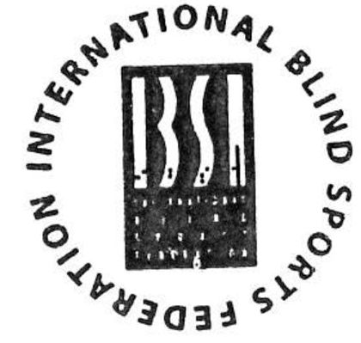
Zdeněk Barlok
IBSA Tenpin bowling Chairman
Prague, 17th May 2023

